Republic of the Philippines

University of Southeastern Philippines

College of Engineering

Bo. Obrero Campus, Davao City



A Proposed Study on

**“An On-Road Kinetic Energy Harvester Using Electromagnetic: Gear and Generator Type Technologies”**

In Partial Fulfillment of the Requirements for

ES 108: Methods of Engineering Research/Undergraduate Thesis

Submitted to:

Engr. Kathleen Cedeño

Submitted by:

Castillo, Solomon F.

May 2019

Table of Contents

Chapter I 3

1.1 Background of the Study 3

1.2 Statement of the Problem 4

1.3 Objectives of the Study 4

1.4 Framework 5

1.5 Significance of the Study 5

1.6 Scope and Limitations 6

Chapter II 7

2.1 Related Legal Bases 7

2.1.1 Republic Act No. 4136 7

2.1.2 Republic Act No. 9513 7

2.1.3 Department Order No. 68 7

2.2 Related Literature 7

2.2.1 Energy Harvester 7

2.2.2 Types of Energy Harvesters 8

2.2.3 Renewable Energy Sources 8

2.2.4 Mechanical Motion Rectifier 8

2.3 Related Studies 8

2.3.1 Large Scale Energy Harvesters 8

2.3.2 Energy Harvesting Principles and Technologies 9

2.3.3 Energy Harvesting Technologies on Vehicles 11

2.3.4 On-road Energy Technology 12

2.4 Justification of the Proposed Study 12

Chapter III 13

3.1 Research method 13

3.2 Materials and methods 13

3.3 Procedure 14

3.4 Evaluation of products 15

Schedule of Activities / Timeline 16

REFERENCES 17

APPENDIX 21

CURRICULUM VITAE OF THE PROPONENT 23

# Chapter I

**Introduction**

## 1.1 Background of the Study

Most of the energy that the world is using today comes from non-renewable energy sources. Non-renewable energy sources or fossil fuels like coal, crude oil, and natural gases are all very limited while the amount of energy that the world is using is only increasing in number. (“Nonrenewable Energy Sources - Energy Explained, Your Guide To Understanding Energy - Energy Information Administration,” 2018) This is the reason why the search or development of new renewable energy sources and improvement of present renewable energy sources are always being conducted.

Advancements in renewable energy technologies like solar power, hydroelectric, wind power, geothermal power, and other forms of renewable energy technologies have been very beneficial in helping the world with its problems with limited power. However, this is still not enough. There is still a need for more sources of renewable energy.

In the Philippines alone, the total consumption of electric energy per year is 78.30 billion kWh, while the amount of electricity that the Philippines is self-producing is 86.59 billion kWh per year, 111% of the country’s own requirements. The amount of electric energy that the country is producing is only expected to decrease with time due to the steady decrease of the contribution of renewable energy sources to the production of electric energy in the country. In 2015, renewable energy sources of the Philippines, which includes wind, solar, biomass, and geothermal energy sources, only accounted for 27.5 percent of the total energy consumption of the country – a big difference when compared to the country’s energy situation in 1990, wherein renewable energy sources accounted for more than half of the total energy consumption of the Philippines. (“Energy consumption in the Philippines,” 2016)

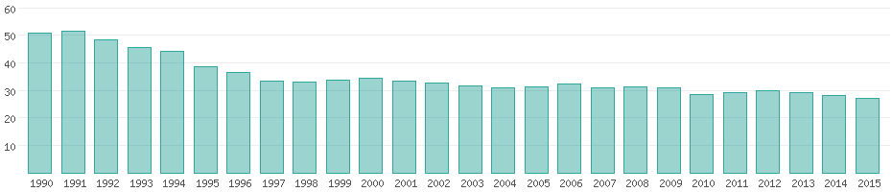

Figure 1. The percentage share of renewable energy sources from 1990 to 2015. Taken from https://www.worlddata.info/asia/philippines/energy-consumption.php.

The proponent proposes the design of an on-road kinetic energy harvester that utilizes the large population of vehicles in the country by producing renewable energy out of the kinetic energy that is present between the moving vehicles and the road. Kinetic energy harvesting has been subject to research for over a decade due to its versatility and potential for the improvement of present renewable energy sources and development of new ones. The conversion of kinetic energy to electric energy is not new, as some of the already present renewable energy sources already follow this principle. However, the use of moving vehicles and the road as the source of kinetic energy for electromagnetic: gear and generator type technologies has never been done before.

This research would attempt to create a reliable source of renewable energy by using electromagnetic principles, and by taking advantage of the kinetic energy present between the relationship of concrete roads and the vehicles moving on it. To validate the concept of this proposed study, computer-aided modeling and simulation will be conducted.

## 1.2 Statement of the Problem

For decades, researchers have struggled to find more sources of renewable energy because the amount of energy that the world has is very limited. Solar power, wind power, hydroelectric power, and geothermal power are great sources of renewable energy, however, these will not suffice. It won’t take long until the world runs out of non-renewable resources, by then, the world will have to rely solely on our renewable energy sources (Davison, 1998).

In the Philippines, the scarcity of electric energy is also present and can be observed. Before the country exhausts its non-renewable energy sources, ways to improve present and develop new renewable energy sources should be researched.

The problem that this study is trying to address is the energy crisis that is present in the Philippines and throughout the world. The limited amount of non-renewable energy sources is a threat to the energy situation because most of the electric energy being produced is from non-renewable energy sources.

The conversion of kinetic energy to electric energy is a very promising subject that can be of significant help in the advancements in the search for new renewable energy and the improvement of the already existing renewable energy sources.

## 1.3 Objectives of the Study

The following are the objectives of this study:

* to design a functional energy harvester that collects the kinetic energy from the moving vehicles on the road, and transform the collected kinetic energy to electrical energy with the use of electromagnetic: gear and generator principles and technologies for later use;
* to analyze the properties and quantity of the energy harvested using the on-road kinetic energy harvester, and;
* to provide recommendations regarding further research that can be done with the on-road kinetic energy harvester that is within and outside the scope and limitations of the study.

## 1.4 Framework

Figure 2 shows the independent, intervening, and dependent variable for the conceptual framework of the proposed study.

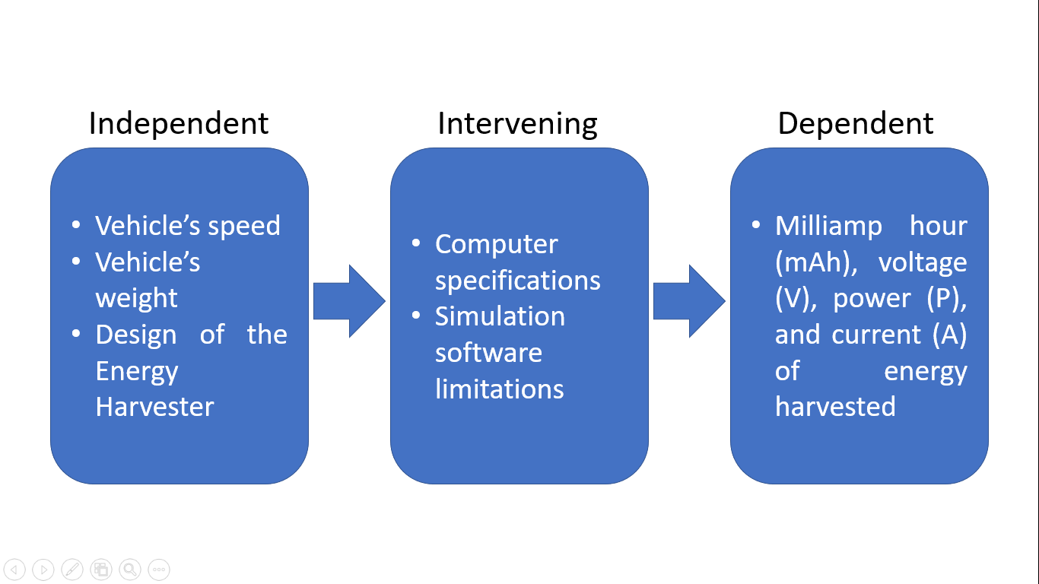

Figure 2. Conceptual framework

Researcher-controlled variables such as the weight and speed of the vehicles to be used and the type of generator used are the independent variables of this research. Since the experimentation will be conducted through a simulation, the experiment will be dependent on the specifications of the computer that will be used for the simulation and the limitations of the simulation software that will be used, thus, these are the intervening variables. Lastly, the properties of the harvested energy are the dependent variables of this research.

## 1.5 Significance of the Study

If the design of the proposed on-road kinetic energy harvester of the study proves to be functional and effective as a renewable source of energy, the on-road kinetic energy harvester will prove to be useful to the following entities:

* Proponent - This study will serve as the product of the theories, laws, and practices that the proponent has learned and experienced while studying mechanical engineering and related subjects.
* Energy Sector - The on-road kinetic energy harvester could serve as a viable solution to the energy crisis that the country is facing.
* Government - The on-road kinetic energy harvester could be added to the pool of renewable energy technologies that the government has, making it an available option for places that has wide, long roads and dense vehicle population.
* Future Research - With further research and development, the on-road kinetic energy harvester could pose to be as an equal or better renewable energy source than the already present renewable energy sources like solar power, wind power, hydroelectric power, and geothermal power.

Lastly, the proponent aims to develop the proposed on-road kinetic energy harvester in line with one of the university’s research agenda. Specifically, the proposed project falls under Power Generation and Renewable Energy of Cluster A: Technology Generation and Energy Efficiency of the university’s research agenda.

## 1.6 Scope and Limitations

This study only involves the design and analysis of an on-road kinetic energy harvester, and nothing more. With that said, the storage for any of the energy that will be harvested is outside the scope of the study. Additionally, the load for the said energy harvested is also not included in the scope of the study. However, the amount of energy harvested, and its properties will be observed and analyzed.

In this paper, electric generators are not new, but the application is. Therefore, the use of an already existing electric generator in the design of the on-road kinetic energy harvester is within the scope and limitation of this study. Optimization and modification in the model electric generator that will be used for the simulation are also within the scope of this study.

The type of road that will be used for this study is flat concrete or cement road in dry and wet conditions. Muddy, sandy, broken, underdeveloped, and unfinished roads are outside the scope of the limitation.

As for the vehicular variables of the study, only 2-wheeled motorcycles, hatchbacks, pick-ups, and SUVs are included in the scope of the study - any other variations are outside the limitations of the study.

The study will be conducted at the University of Southeastern Philippines, Obrero Campus, Davao City for the year 2019.

# Chapter II

**Review of Related Literature**

## 2.1 Related Legal Bases

### 2.1.1 Republic Act No. 4136

Republic Act No. 4136 is also known as the Land Transportation and Traffic Code. This law sets the legal speed limits and penalties for traffic violations. The speed limit according to this law will be observed during the experimentation of this research.

### 2.1.2 Republic Act No. 9513

Republic Act No. 9513 is also known as the Renewable Energy Law. This law encourages the development, improvement, and use of non-traditional energy sources. The on-road kinetic energy harvester is a renewable energy source, and can, therefore, be classified as a non-traditional energy source.

### 2.1.3 Department Order No. 68

Department Order No. 68 of the Department of Public Works and Highways states the prescribed minimum design standards for industry roads. The prescribed minimum for the width of a cement concrete pavement is 6.70 meters for two lanes, while the minimum thickness is 280 millimeters.

Moreover, the minimum vehicular speeds for each type of terrain are also stated. For flat terrain, a minimum of 60 kph must be observed, 40 kph for rolling terrain, and 30 kph for mountainous terrain.

These requirements will be followed in the methodology of the proposed study.

## 2.2 Related Literature

### 2.2.1 Energy Harvester

An energy harvester is a device that is capable of energy harvesting. Energy harvesting is the process of deriving electrical energy from the collected ambient energy like thermal, solar, wind, and kinetic energy. Most of the energy harvesters that are present nowadays use electric generators.

An electric generator is a device that converts specific forms or mechanical energy into electrical energy. In other words, a generator is the opposite of an electric motor when it comes to functionality. Generators can produce direct or alternating current, however, alternating current generators are often referred to as alternators (De Luna, De Luna, & Manzano, 2012).

The basic structure of an electric generator or dynamo consists of a magnet and a loop of wire placed between the poles of the magnet (World Book International, 1994a). An electric current flows along the coil of wire in the magnetic field between the north and south pole when the coil of wire is rotated by a mechanical engine or a mechanical motion (World Book International, 1994b).

### 2.2.2 Types of Energy Harvesters

There are different types of energy harvesters, the existing ones are always researched and improved, while new ones are always being developed. Energy harvesters range from the collection of thermal energy (Boughaleb et al., 2018), solar energy (H. Li, Zhang, & You, 2016), wind energy (Wang, Li, Zhou, & Litak, 2019), kinetic energy (Abadi, Darlis, & Suraatmadja, 2018), and vibration energy (Machů, Majer, Ševeček, Štegnerová, & Hadaš, 2018).

Identifying the advantages and disadvantages of the different types of energy harvesters is useful to the proposed study.

### 2.2.3 Renewable Energy Sources

Renewable energy is a type of energy that is harvested from renewable sources, these renewable sources include sunlight, wind, heat, waves, and tides. Renewable energy is often experienced or used in the form of electricity or electrical energy. Research regarding the improvement and development of renewable energy sources are always being conducted.

Due to the limited amount of non-renewable energy sources, renewable energy sources are constantly being studied and integrated into modern society, architecture, engineering, and lifestyle. Wearable devices that are capable of harvesting energy from the kinetic motion of the wearer was developed to utilize the kinetic motion that humans make (Young-Man Choi, Moon Lee, & Yongho Jeon, 2017). In terms of engineering and architecture, modular buildings that are powered by renewable energy sources have also been developed (Tauš, Taušová, Šlosár, & Je, 2015).

### 2.2.4 Mechanical Motion Rectifier

A mechanical motion rectifier is a device that converts bidirectional motion to unidirectional motion. This device works particularly well with devices that need a uniform unidirectional motion from a source with bidirectional motion. In the study of Li et al. (2013), they added a mechanical motion rectifier to their energy harvesting shock absorber. Both the upward and downward kinetic motion of the shock absorber were properly harvested and converted to electrical energy due to the addition of the mechanical motion rectifier (Z. Li, Zuo, Kuang, & Luhrs, 2013).

Young-Man Choi et al. (2017) also attached a mechanical motion rectifier to their wearable energy harvesting device to effectively harvest the motion of the left and right foot of a walking human (Young-Man Choi et al., 2017).

## 2.3 Related Studies

### 2.3.1 Large Scale Energy Harvesters

Energy harvesters have been thoroughly researched by the proponent because they play a vital role in this research. Energy harvesting, nowadays, is understood as the conversion of ambient and abundant energy in the environment into electrical energy (Cepnik, Lausecker, & Wallrabe, 2013). One of the most important things that must be considered in an energy harvester is the energy harvesting technology that it uses.

One of the current renewable energy sources that Japan is utilizing is the waves brought by their ocean current (Katsutoshi Shirasawa, Junichiro Minami, & Tsumoru Shintake, 2017). To be able to collect the kinetic energy of the ocean current, Katsutoshi Shirasawa, Junichiro Minami, & Tsumoru Shintake (2017) designed an ocean current turbine that can be brought to the seabed and function like a wind turbine. To keep the ocean current turbine upright, a floater was placed on top and a counterweight was placed at the bottom (Katsutoshi Shirasawa et al., 2017). With the waves only having a flow speed of 1 to 1.5 m/s, the ocean current turbine was able to generate an output power of 1 kW (Katsutoshi Shirasawa et al., 2017).

The force that the ocean current can exert cannot compare to the force that a vehicle applies to the ground. However, the information gathered from the research of Katsutoshi Shirasawa, Junichiro Minami, & Tsumoru Shintake (2017) is still useful and significant for this research. The output values of their research provide a clear reference point as to what the proponent can expect from this research.

### 2.3.2 Energy Harvesting Principles and Technologies

There are a lot of energy harvesting principles and technologies to be considered when trying to design a renewable energy technology. One of the most ambient forms of energy that has a lot of potential to be a renewable energy source is vibration. Vibration is present in almost every system that exists outside vacuum conditions. This is the reason why vibration energy harvesting has been the focus of many types of researches regarding energy harvesting over the last decade (Z. Liu, Wang, Zhang, & Wang, 2018).

Vibration energy harvesters often use electromagnetic or piezoelectric principles; modifications to existing systems have been studied over the years to try and improve the efficiency and effectivity of these energy harvesters. The vibration energy harvester of Kulik et al, (2018) involved the use of magnetic springs to allow the energy harvester to operate on low-frequency vibrations (Kulik, Gabor, & Jagieła, 2018).

The piezoelectric vibration energy harvester of Zhang et al. (2016) used ropes to drive the energy harvesting process, effectively making multiple low-frequency driving beams to drive a high frequency generating beam, maximizing the amount of energy that can be harvested from minimal or low-frequency energies (Zhang et al., 2016). The methodology of Zhang et al. (2016) can be useful to the researcher, especially when the amount of energy that is being harvested is below the expected amount. By making the low-frequency beams run the high-frequency beams, more energy can be harvested. As for turning low-frequency energies to high frequency, a mechanical frequency up-conversion technology can also be used (Xu et al., 2017). The design of Xu et al. (2017) for their up-converting frequency hybrid energy harvester was based on the combination of piezoelectric mechanisms and electromagnetic transduction mechanism (Xu et al., 2017). To cope with the inconsistent and fluctuating frequencies of the vibration systems, Liu et al. (2015) designed an array of energy harvesters that uses multiple vibration modes. The design proved to be an effective approach to harvesting energy from vibration systems with varying frequency peaks (H. Liu, Chen, Sun, & Lee, 2015). Rahim et al. (2018) used dual moving mechanical systems on their energy harvesters to operate at multiple low resonance frequencies. The use of dual moving mechanical systems made the energy harvester more versatile to low frequencies and it also increased the amount of voltage that was produced from harvesting energy, harvesting 108 mV with 78 µW or power (Rahim, Hamid, Yusuf, Soid, & Ibrahim, 2018).

To satisfy both low and high vibration frequencies, Li et al. (2018) designed an energy harvester that uses piezoelectric and electromagnetic energy harvester principles. As a result, the output power and efficiency in the harvesting of the hybrid energy harvester have been enhanced (P. Li, Gao, & Cong, 2018). Xu et al. (2016) made a somewhat similar energy harvester, the difference is that the hybrid energy harvester used conversion mechanisms that switched the energy harvester’s system from piezoelectric to electromagnetic, and vice versa (Xu, Shan, Chen, & Xie, 2016).

Another way to harvest vibration energy is with the use of microelectromechanical systems energy harvester or MEMS energy harvester. The average amount of energy harvested in electrical circuits using MEMS energy harvester is 100 µW (Toshiyoshi, Ju, Honma, Ji, & Fujita, 2019). Considering that the Bluetooth 4.0 in a device that equipped with it uses 45 mW of power at 15 mA and 3.6 V at peak power, using MEMS energy harvesters on its circuit board isn’t very useful. MEMS energy harvesters are useful in devices that only use about 100 µW of power (Toshiyoshi et al., 2019).

Yan et al. (2018) found the potential in harvesting the kinetic motion of humans, specifically the motion of the knee joint, to produce electric energy (Yan, Zhang, & Li, 2018). Yan et al. (2018) designed and fabricated a magnetostrictive energy generator that generates electricity by harvesting the rotational motion of the knee joint. The magnetostrictive energy generator was able to produce 60 to 80 volts at a low-frequency rotation of 0.91 Hz (Yan et al., 2018).

Terlecka et al. (2014), in their research about wearable energy harvesters, found that the optimal position for a wearable electromagnetic energy harvester is in the anterior superior iliac spine level (Terlecka, Blums, Vilumsone, Gornevs, & Pavare, 2014).

On Young-Man Choi, Moon Lee, & Yongho Jeon’s research (2017), they analyzed and compared different wearable energy harvesting technologies. Young-Man Choi et al. (2017) focused on finding the most efficient wearable energy harvester and capable of generating watt-level power at the same time (Young-Man Choi et al., 2017).

From the data of Young-Man Choi et al. (2017), the piezoelectric energy harvester peaked at 90.3 mW per step of output power. (Young-Man Choi et al., 2017) The triboelectric nanogenerator that uses the triboelectrification principle, on the other hand, made a foot strike generate 4.9 mW of power (Young-Man Choi et al., 2017). Coming from the same source, a foot strike, Young-Man Choi, Moon Lee, & Yongho Jeon’s (2017) electromagnetic inertial induction type experiment generated 8.5 mW of power.

Young-Man Choi et al. (2017) found that an electromagnetic: gear and generator type energy harvester is capable of producing 5.6 W of power when the energy harvester is attached to the center of gravity of a body moving at 5.6 km/h (Young-Man Choi et al., 2017).

The study of Young-Man Choi et al. (2017) on wearable energy harvesters is significant in this study because the proponent aims to create an on-road kinetic energy harvesting device that can produce watt-level power. If Young-Man Choi, Moon Lee, & Yongho Jeon’s (2017) electromagnetic gear and generator type can produce 5.6 W from foot strike, the proponent can expect a higher power output when the source of the energy is from the contact of the wheels of a moving vehicle on the road (Young-Man Choi et al., 2017).

### 2.3.3 Energy Harvesting Technologies on Vehicles

Through the years, research to reduce the amount of fuel consumption of vehicles to increase efficiency and protect the environment has been carried out. Researchers have been trying to recover the vibration energy from the suspension systems of vehicles with the use of different vibration energy harvesters. Sultoni et al. (2013) compared the amount of energy that a rotary electromagnetic generator and a linear electromagnetic generator can produce from the suspension system of a quarter car. The rotary generator was able to harvest 0.25 milliwatts of power, while the linear generator was able to harvest 90 watts of power (Sultoni, Sutantra, & Pramono, 2013).

On Vaskovskyi, Poda, & Koshikar’s research (2018), they placed a device that converts translational motion to rotational motion to the chassis of a vehicle to harness the mechanical oscillations in the chassis and turn them into rotational motions. Those rotational motions will then drive an electric generator, the power produced will run on a rectifier before it is stored in a battery (Vaskovskyi, Poda, & Koshikar, 2018)**.** The study of Vaskovskyi, Poda, & Koshikar (2018) proves that even the smallest amount of energy that is usually lost in the shock absorber can still be absorbed and turned into useful energy that can be utilized for later use (Vaskovskyi et al., 2018).

Another study that harnesses the vibration energy from a moving vehicle for later use is the research of Nam, Chun, Ha, & Kim (2017). Most of the experimental aspect of their research was done in a simulation (Nam, Chun, Ha, & Kim, 2017). Nam et al. (2017) attached an electric generation system that is linear to the part of the vehicle that mostly absorbs all of the vibration, the shock absorber (Nam et al., 2017). Through the use of the PIDO software PIAnO, the entire design of the electric generator system has been optimized to induce 3106.56 mV from 271.57 mV (Nam et al., 2017).

The study of Bucinskas et al. (2017) also focuses on the energy harvesting potential on moving vehicles, but with an added variable – Bucinskas et al. (2017) also considered the comfort level of the driver and passengers by controlling the level of damping of the vehicle (Bucinskas et al., 2017). Though the objectives might seem to contradict as you need vibration to harness energy and damping reduces the amount of vibrations on a moving vehicle, the researchers were still able to produce significant results in their research (Bucinskas et al., 2017).

Bucinskas et al. (2017) paired electromagnetic transducers and piezoelectric energy harvesting technologies in the design of their energy harvesting device (Bucinskas et al., 2017). The device was still placed on the suspension system of the vehicle and the researchers, Bucinskas et al., were only expecting milliwatt-level of power output due to the nature and limitations of piezoelectric energy harvesters (Bucinskas et al., 2017).

Bucinskas et al. (2017) were able to find the optimal damping coefficient, the point where the amount of energy harvested is maximized while the comfort of the passengers isn’t compromised, using the polynomial damping law (Bucinskas et al., 2017). At the end of their research, the researchers concluded that their method can be applied to harness more energy from the suspension system of common vehicles.

### 2.3.4 On-road Energy Technology

The idea of attaching something on the road for improvements in science, lifestyle, and ecological help isn’t entirely new anymore. As a matter of fact, the research of Tan et al. (2016) is focused on strategizing a way to effectively charge electric vehicles by placing on-road chargers for electric vehicles (Tan et al., 2016).

To fully realize on-road charging for electric vehicles, Tan et al. (2016) stated in their research that roads must be reconstructed, and electric vehicles must have an extra attachment. To be more specific, energy transmitting coils must be placed under the roads and energy receiving coils must be placed under electric vehicles to make on-road electric vehicle charging possible (Tan et al., 2016).

Other than that, Tan et al. (2016) also analyzed power charging strategies. Their research objective included electric vehicle prioritization, electric charging stability, electric charging limitation, and electric charging safety (Tan et al., 2016).

Research like this helps this study to know its level of plausibleness. Knowing that wireless power transmission is possible from this research, reassures the proponent that a much simpler concept, yet arguably similarly significant design is possible.

The study of Song et al. (2016) involved the design of a road energy harvester that provides macro-power energy source using piezoelectric energy harvesters (Song et al., 2016). The difference between the study of Song et al. (2016) and the proposed study is that the proposed study will utilize electromagnetic effects when harvesting energy, and not piezoelectric effect. The proposed study will also provide watt-level power and not macro-power.

## 2.4 Justification of the Proposed Study

The components for this study to be done like energy harvesting technologies, electromagnetic principles, mechanoelectrical mechanisms, and on-road attachments have been thoroughly researched in the past. There are a lot of studies that suggest the plausibility of the proposed study. If it were to be successful, this study could drastically help in the energy crisis of the Philippines, even the world.

The abundant highways that our cities have and the increasing population of vehicular traffic should be looked at as an advantage. An on-road kinetic energy harvester would be very beneficial to cities or places with wide and long roads and plentiful vehicles.

For further studies and advancements in this research, the possibilities of kinetic energy storage as buffers for harvested energy should be considered. Having kinetic energy storage available could greatly help the main source or storage of energy in vehicles or cities – the electric battery (Jivkov & Draganov, 2017).

# Chapter III

**Materials & Methods**

## 3.1 Research method

The proposed study will be classified and treated as applied research because the proposed design of the on-road kinetic energy harvester utilizes multiple known knowledge in the field of physics, electronics, mathematics, and engineering. Moreover, one of the objectives of the proposed study is to have a basic and acceptable solution to a problem that the country is facing – the energy crisis.

Due to the nature of the proposed study and its objectives, the research design of the proposed study will be classified and treated as an experimental design. The proponent plans to approach the proposed study as so. Since the experiment will be done through computer simulation, the proponent will collect and analyze the effects of the independent variable on the dependent variable for a relationship and improve the design of the proposed on-road kinetic energy harvester.

## 3.2 Materials and methods

Computer-aided modeling and simulation will be used to test and validate the design of the proposed on-road kinetic energy harvester. With that said, the following are the materials and tools required to conduct the proposed study:

* Computer – since the modeling and testing of the design will be done through a computer simulation, a working computer that can run 3D physics simulation software and 3D modeling software is required.
* AutoCAD - AutoCAD is a computer-aided design, drawing, and drafting software developed by Autodesk. The proponent will model the necessary tools and environmental conditions that will be used in the simulation using this software. The design and modeling of the on-road kinetic energy harvester will also be done using this software.
* ANSYS Academic – ANSYS Academic is an engineering simulation software developed by ANSYS. This software can run complex 3D physics simulations and effectively import computer-aided drawings to be used in the simulation, a feature that is needed to proceed with the study.

The initial conceptual design of the on-road kinetic energy harvester is as follows:

1. A pressure plate will receive kinetic motion from a moving vehicle upon contact.
2. The pressure plate will cause a gear rack to move downward.
3. The downward motion of the gear rack will cause the electromagnetic generator to function, thus, converting the kinetic motion to electrical energy.
4. A spring will cause the gear rack to move upward and force the pressure plate back to its initial state.
5. A mechanical motion rectifier will ensure that the upward motion of the gear rack will also cause the electromagnetic generator to function.
6. The upward motion of the gear rack will also be converted to electrical energy by the electromagnetic generator due to the mechanical motion rectifier.
7. The converted electrical energy can either be connected to a working load or stored in a battery.

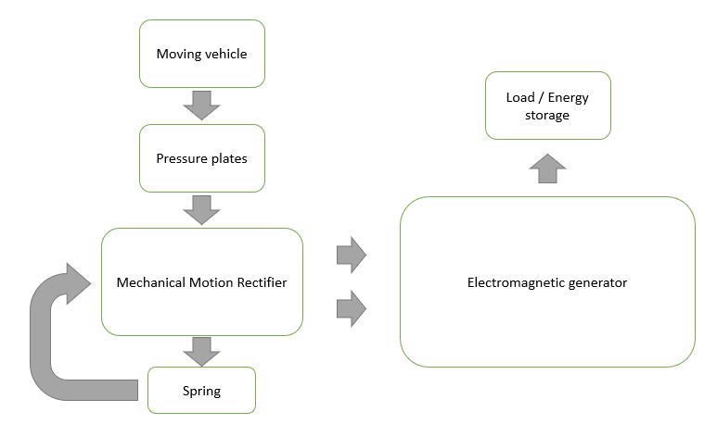

Figure 3. Initial block diagram of the flow of energy of the on-road kinetic energy harvester

In an event where the pressure plate is repeatedly activated by a high population of moving vehicles, the mechanical motion rectifier will keep the electromagnetic generator functioning properly. The repetitive upward and downward motion of the gear rack will be converted into a unidirectional motion for the electromagnetic generator to utilize.

The dimensions of the cement concrete road and the minimum vehicular speed for each road terrain type will be based on the Department Order no. 68 of the Department of Public Works and Highways.

Table 1. Road dimensions and design speed according to DO no.68. Taken from Department Order no. 68 of DPWH (To view the original table, refer to Appendix A).

|  |  |
| --- | --- |
| Dimensions | |
| Width | 6.70 m for two lanes |
| Thickness | 280 mm |
| Design Speed | |
| Flat | 60 kph |
| Rolling | 40 kph |
| Mountainous | 30 kph |

## 3.3 Procedure

To effectively address all the objectives of the proposed study, the proponent plans to follow these steps:

1. Initial calculations – the initial calculations comprise of the standard dimensions of the urban roads in the Philippines, the dimensions of the vehicles that will be used for the proposed study, the weight of the said vehicles, the weight of some of the particular components of the vehicles, height of the optimal obstruction on the road that will not compromise driver and passenger comfort, and speed of the vehicles that will be simulated.
2. Modeling of the non-energy harvester related components of the study (Modeling 1) – after obtaining the necessary dimensions of the independent variables involved, the 3D computer modeling of the said involved independent variables will follow.
3. Modeling of the on-road kinetic energy harvester (Modeling 2) – once the independent variables are modeled, the 3D modeling of the on-road kinetic energy harvester using AutoCAD will follow.
4. Simulation – after all the necessary tools and variables are set, the involved 3D models shall be integrated into ANSYS Academic, to begin with the simulation.
5. Tabulation of results from simulation – the dependent variables will be collected and analyzed after the simulation for the on-road kinetic energy harvester has been conducted.
6. Optimization of the design – if the proponent finds a room for improvement that can still be addressed within the limited time frame of the proposed research, the said improvement will be attempted to be done. Remodeling and the simulation of the on-road kinetic energy harvester will be done when deemed necessary and still within the schedule of activities for the proposed study.
7. Finalization of the product – once the optimization for the on-road kinetic energy harvester has finished, the finalization of the product of the proposed study shall be done. The results of the final simulation will be collected and compared to all the previous simulations conducted, and recommendations for the improvement of the on-road kinetic energy harvester will be presented.

## 3.4 Evaluation of products

The final product must be able to address all the set objectives of the proposed study:

* the final simulation or the product of the proposed study must showcase the functionality of the designed energy harvester, and;
* the product of the proposed study must be able to collect kinetic energy from moving vehicles on the road and transform the collected energy for later use.

# Schedule of Activities / Timeline

The figure below shows the timeline or the schedule of activities for the proposed project. The proposed project will be conducted in the first semester of S.Y. 2019 – 2020.

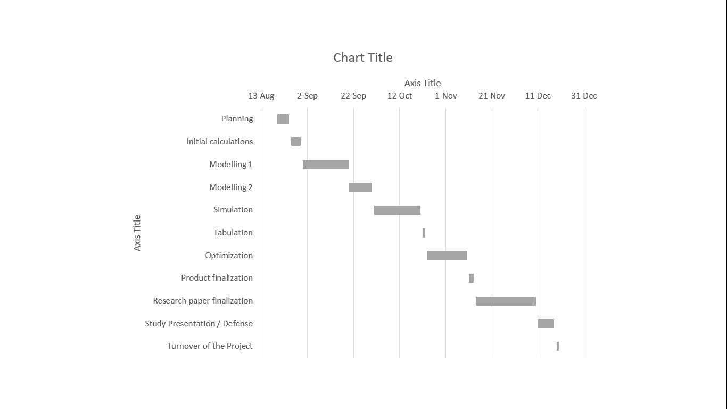

Figure . Proposed schedule of activities.

# REFERENCES

Abadi, P. B., Darlis, D., & Suraatmadja, M. S. (2018). Green energy harvesting from human footsteps. *MATEC Web of Conferences*, *197*, 11015. https://doi.org/10.1051/matecconf/201819711015

Boughaleb, J., Arnaud, A., Guiffard, B., Guyomar, D., Seveno, R., Monfray, S., … Cottinet, P.-J. (2018). Coupling of PZT Thin Films with Bimetallic Strip Heat Engines for Thermal Energy Harvesting. *Sensors*, *18*(6), 1859. https://doi.org/10.3390/s18061859

Bucinskas, V., Mitrouchev, P., Sutinys, E., Sesok, N., Iljin, I., & Morkvenaite-Vilkonciene, I. (2017). Evaluation of Comfort Level and Harvested Energy in the Vehicle Using Controlled Damping. *Energies*, *10*(11), 1742. https://doi.org/10.3390/en10111742

Cepnik, C., Lausecker, R., & Wallrabe, U. (2013). Review on Electrodynamic Energy Harvesters—A Classification Approach. *Micromachines*, *4*(2), 168–196. https://doi.org/10.3390/mi4020168

Davison, A. (1998). Renewable Energy, forms and types of renewable energy. Retrieved April 23, 2019, from Alternative Energy - Wind, Solar, Hydro and other alt energy sources for commercial and home power website: http://www.altenergy.org/renewables/renewables.html

De Luna, M. J. M., De Luna, L. H., & Manzano, R. P. (2012). *Exploring Science & Technology - Physics*. Anvil Publishing, Inc.

Energy consumption in the Philippines. (2016). Retrieved April 24, 2019, from Worlddata: The world in numbers website: https://www.worlddata.info/asia/philippines/energy-consumption.php

Jivkov, V., & Draganov, D. (2017). The Kinetic Energy Storage as an Energy Buffer for Electric Vehicles. *Advances in Automobile Engineering*, *06*(02). https://doi.org/10.4172/2167-7670.1000165

Katsutoshi Shirasawa, Junichiro Minami, & Tsumoru Shintake. (2017). Scale-Model Experiments for the Surface Wave Influence on a Submerged Floating Ocean-Current Turbine. *Energies*, *10*(5), 702. https://doi.org/10.3390/en10050702

Kulik, M., Gabor, R., & Jagieła, M. (2018). Analysis of vibration energy harvester with magnetic spring. *ITM Web of Conferences*, *19*, 01030. https://doi.org/10.1051/itmconf/20181901030

Li, H., Zhang, G., & You, Z. (2016). Optimization Design and Simulation of a Multi-Source Energy Harvester Based on Solar and Radioisotope Energy Sources. *Micromachines*, *7*(12), 228. https://doi.org/10.3390/mi7120228

Li, P., Gao, S., & Cong, B. (2018). Theoretical modeling, simulation and experimental study of hybrid piezoelectric and electromagnetic energy harvester. *AIP Advances*, *8*(3), 035017. https://doi.org/10.1063/1.5018836

Li, Z., Zuo, L., Kuang, J., & Luhrs, G. (2013). Energy-harvesting shock absorber with a mechanical motion rectifier. *Smart Materials and Structures*, *22*(2), 025008. https://doi.org/10.1088/0964-1726/22/2/025008

Liu, H., Chen, T., Sun, L., & Lee, C. (2015). An Electromagnetic MEMS Energy Harvester Array with Multiple Vibration Modes. *Micromachines*, *6*(8), 984–992. https://doi.org/10.3390/mi6080984

Liu, Z., Wang, X., Zhang, R., & Wang, L. (2018). A Dimensionless Parameter Analysis of a Cylindrical Tube Electromagnetic Vibration Energy Harvester and Its Oscillator Nonlinearity Effect. *Energies*, *11*(7), 1653. https://doi.org/10.3390/en11071653

Machů, Z., Majer, Z., Ševeček, O., Štegnerová, K., & Hadaš, Z. (2018). Electro-mechanical analysis of a multilayer piezoelectric cantilever energy harvester upon harmonic vibrations. *MATEC Web of Conferences*, *210*. https://doi.org/10.1051/matecconf/201821002053

Nam, K. H., Chun, Y. D., Ha, Y.-S., & Kim, J. H. (2017). Linear electric generation system to harvest vibration energy from a running vehicle. *Journal of Vibroengineering*, *19*(6), 4009–4017. https://doi.org/10.21595/jve.2017.17831

Nonrenewable Energy Sources - Energy Explained, Your Guide To Understanding Energy - Energy Information Administration. (2018). Retrieved April 23, 2019, from U.S. Energy Information Administration (EIA) website: https://www.eia.gov/energyexplained/?page=nonrenewable_home

Rahim, M. Z. A., Hamid, M. N. H., Yusuf, Z. N. M., Soid, S. N. M., & Ibrahim, M. R. (2018). Modeling and Experiment of Electromagnetic Energy Harvester System by Using Dual Moving Mechanical Systems at Low Frequency Range. *MATEC Web of Conferences*, *217*, 02006. https://doi.org/10.1051/matecconf/201821702006

Song, Y., Yang, C. H., Hong, S. K., Hwang, S. J., Kim, J. H., Choi, J. Y., … Sung, T. H. (2016). Road energy harvester designed as a macro-power source using the piezoelectric effect. *International Journal of Hydrogen Energy*, *41*(29), 12563–12568. https://doi.org/10.1016/j.ijhydene.2016.04.149

Sultoni, A. I., Sutantra, I. N., & Pramono, A. S. (2013). Vibration Energy Harvesting on Vehicle Suspension Using Rotary and Linear Electromagnetic Generator. *IPTEK The Journal for Technology and Science*, *24*(1). https://doi.org/10.12962/j20882033.v24i1.136

Tan, L., Guo, J., Huang, X., Liu, H., Yan, C., & Wang, W. (2016). Power Control Strategies of On-Road Charging for Electric Vehicles. *Energies*, *9*(7), 531. https://doi.org/10.3390/en9070531

Tauš, P., Taušová, M., Šlosár, D., & Je, M. (2015). *Optimization of energy consumption and cost effectiveness of modular buildings by using renewable energy sources*. *20*(3), 9.

Terlecka, G., Blums, J., Vilumsone, A., Gornevs, I., & Pavare, Z. (2014). Wearable power Harvester for medical applications. *SHS Web of Conferences*, *10*, 00046. https://doi.org/10.1051/shsconf/20141000046

Toshiyoshi, H., Ju, S., Honma, H., Ji, C.-H., & Fujita, H. (2019). MEMS vibrational energy harvesters. *Science and Technology of Advanced Materials*, *20*(1), 124–143. https://doi.org/10.1080/14686996.2019.1569828

Vaskovskyi, Yu. M., Poda, M. V., & Koshikar, I. V. (2018). ELECTRIC GENERATOR IN THE RECUPERATION SYSTEM OF THE ENERGY FROM MECHANICAL OSCILLATIONS IN VEHICLES. *Electrical Engineering & Electromechanics*, *0*(5), 24–28. https://doi.org/10.20998/2074-272X.2018.5.04

Wang, J., Li, G., Zhou, S., & Litak, G. (2019). Enhancing Wind Energy Harvesting Using Passive Turbulence Control Devices. *Applied Sciences*, *9*(5), 998. https://doi.org/10.3390/app9050998

World Book International. (1994a). *Young Scientist: Introducing Electricity* (Vol. 10). Chicago, U.S.A.: World Book, Inc.

World Book International. (1994b). *Young Scientist: Magnetic Power* (Vol. 11). Chicago, U.S.A.: World Book, Inc.

Xu, Z., Shan, X., Chen, D., & Xie, T. (2016). A Novel Tunable Multi-Frequency Hybrid Vibration Energy Harvester Using Piezoelectric and Electromagnetic Conversion Mechanisms. *Applied Sciences*, *6*(1), 10. https://doi.org/10.3390/app6010010

Xu, Z., Wang, W., Xie, J., Xu, Z., Zhou, M., & Yang, H. (2017). An Impact-Based Frequency Up-Converting Hybrid Vibration Energy Harvester for Low Frequency Application. *Energies*, *10*(11), 1761. https://doi.org/10.3390/en10111761

Yan, B., Zhang, C., & Li, L. (2018). Magnetostrictive energy generator for harvesting the rotation of human knee joint. *AIP Advances*, *8*(5), 056730. https://doi.org/10.1063/1.5007195

Young-Man Choi, Moon Lee, & Yongho Jeon. (2017). Wearable Biomechanical Energy Harvesting Technologies. *Energies*, *10*(10), 1483. https://doi.org/10.3390/en10101483

Zhang, J., Kong, L., Zhang, L., Li, F., Zhou, W., Ma, S., & Qin, L. (2016). A Novel Ropes-Driven Wideband Piezoelectric Vibration Energy Harvester. *Applied Sciences*, *6*(12), 402. https://doi.org/10.3390/app6120402

# APPENDIX

**Appendix A**





# CURRICULUM VITAE OF THE PROPONENT

Solomon Fernandez Castillo

Catalunan Pequeño, Wellspring Village, Davao City, Philippines [solomoncastillo120@gmail.com](mailto:solomoncastillo120@gmail.com)

(+63)9434810311

(+63)9177282099

**Personal Data:**

Birth date: January 20, 1999

Birth place: Davao City, Philippines

Height: 5 feet and 10 inches

Weight: 75 kgs

Gender: Male

Civil status: Single

Religion: Roman Catholic

Citizenship: Filipino

**Skills and qualifications:**

* Photo editing using Adobe Photoshop
* Video editing using Adobe Premiere
* Video editing using Adobe After Effects
* Computer-aided design using AutoCAD
* C++, JavaScript, HTML programming
* Experienced in MS Office applications

**Educational background:**

|  |  |  |
| --- | --- | --- |
| Tertiary | University of Southeastern Philippines, Obrero, Davao City  Bachelor of Science in Mechanical Engineering | 2015 - present |
| Secondary | Holy Child College of Davao, Tugbok District, Davao City | 2011 - 2015 |

**Seminars and trainings:**

|  |  |
| --- | --- |
| August 16 - 17, 2016 | 4th Junior Philippine Society of Mechanical Engineers Conference  University of Mindanao, Talomo, Davao City |
| August 15 - 16, 2017 | 5th Junior Philippine Society of Mechanical Engineers Conference  University of Southeastern Philippines, Obrero, Davao City |
| August 2018 | 6th Junior Philippine Society of Mechanical Engineers Conference  University of Southeastern Philippines, Obrero, Davao City |